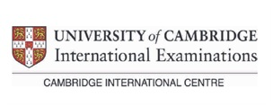 | مراكز ومدارس كامبردج العالمية ( السودان)  Cambridge International Schools & Training Centres ( Sudan)  Approved Centre of University of Cambridge | 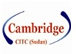

Cambridge International Training Centers (Sudan)
Head Office
Arkaweet - Nakheel Street Extension
Tel - 249-183-521313
Fax - 249-183-521312
P.O.Box - 15018
Web Site- www.citcsudan.org Email learn@citcsudan.org

